電通二甲微處理器實驗 實驗結報

實驗名稱 | Lab06-Music
組別 |  | 組員 | 06050704/林智偉

- 實驗目的
如何使 Arduino 發出特定旋律的聲音?
Arduino 接喇叭如何接線?
如何使用 tone library?
如何演奏一段音樂?
如何使用 4x4 鍵盤演奏音樂?
如何發報摩斯電碼?

- 實驗步驟
Arduino 演奏一段特定的音樂, 旋律不得是小蜜蜂
使用 4x4 鍵盤演奏音樂
發報摩斯電碼

- 程式碼
#1

#define beat 500
#define pin 8
#define NOTE_C3 131
#define NOTE_CS3 139
#define NOTE_D3 147
#define NOTE_DS3 156
#define NOTE_E3 165
#define NOTE_F3 175
#define NOTE_FS3 185
#define NOTE_G3 196
#define NOTE_GS3 208
#define NOTE_A3 220
#define NOTE_AS3 233
#define NOTE_B3 247
#define NOTE_C4 262
#define NOTE_CS4 277
#define NOTE_D4 294
#define NOTE_DS4 311
#define NOTE_E4 330
#define NOTE_F4 349
#define NOTE_FS4 370
#define NOTE_G4 392
#define NOTE_GS4 415
#define NOTE_A4 440
#define NOTE_AS4 466
#define NOTE_B4 494
#define WHOLE 1 //全分符
#define HALF 0.5 //半分符
#define QUARTER 0.25
#define EIGHTH 0.125
#define SIXTEENTH 0.0625
void setup() {
pinMode(8, OUTPUT);
}

void aa (int a, int b, int c){
tone(a,b,c);
delay(c);
noTone(a);
}

void loop() {
aa(pin,NOTE_F4,beat);
aa(pin,NOTE_G4,beat);
aa(pin,NOTE_A4,beat);
aa(pin,NOTE_B4,beat);
aa(pin,NOTE_B4,beat);
aa(pin,NOTE_G4,beat);
aa(pin,NOTE_E4,beat);
}

#2

#include<Keypad.h>
#define beat 500
#define pin 12
#define NOTE_C3 131
#define NOTE_CS3 139
#define NOTE_D3 147
#define NOTE_DS3 156
#define NOTE_E3 165
#define NOTE_F3 175
#define NOTE_FS3 185
#define NOTE_G3 196
#define NOTE_GS3 208
#define NOTE_A3 220
#define NOTE_AS3 233
#define NOTE_B3 247
#define NOTE_C4 262
#define NOTE_CS4 277
#define NOTE_D4 294
#define NOTE_DS4 311
#define NOTE_E4 330
#define NOTE_F4 349
#define NOTE_FS4 370
#define NOTE_G4 392
#define NOTE_GS4 415
#define NOTE_A4 440
#define NOTE_AS4 466
#define NOTE_B4 494
#define WHOLE 1 //全分符
#define HALF 0.5 //半分符
#define QUARTER 0.25
#define EIGHTH 0.125
#define SIXTEENTH 0.0625

const byte ROWS=4,COLS=4;

char keys[ROWS][COLS] =
{{'F', 'E', 'D', 'C'}, {'B','A','9','8'},{'7', '6', '5', '4'}, {'3', '2', '1', '0'}};

byte rowPins[ROWS] = {2,3,4,5};
byte colPins[COLS] = {8,9,10,11};
Keypad keypad = Keypad(makeKeymap(keys),rowPins,colPins,ROWS,COLS);

void setup() {
pinMode(12, OUTPUT);
Serial.begin(9600);
}

void aa(int a, int b, int c){
tone(a,b,c);
delay(c);
noTone(a);
}

void loop() {
char key = keypad.getKey();

if(key!=NO_KEY){
if(key=='0'){
aa(pin,NOTE_C3,500);
}

else if(key=='1'){
aa(pin,NOTE_CS3,500);
}

else if(key=='2'){
aa(pin,NOTE_D3,500);
}

else if(key=='3'){
aa(pin,NOTE_DS3,500);
}

else if(key=='4'){
aa(pin,NOTE_E3,500);
}

else if(key=='5'){
aa(pin,NOTE_F3,500);
}

else if(key=='6'){
aa(pin,NOTE_FS3,500);
}

else if(key=='7'){
aa(pin,NOTE_G3,500);
}

else if(key=='8'){
aa(pin,NOTE_GS3,500);
}

else if(key=='9'){
aa(pin,NOTE_A3,500);
}
}
}

#3

#include<Keypad.h>

void setup() {
pinMode(12, OUTPUT);
Serial.begin(9600);
}

void aa(int a, int b, int c){
tone(a,b,c);
delay(c);
noTone(a);
}

void loop() {
char R;
if(Serial.available())
{
R = Serial.read();
Serial.println(R);
if(R=='A'){
aa(pin,400,100);
delay(100);
aa(pin,400,300);
delay(100);
}

else if(R=='B'){
aa(pin,400,300);
delay(100);
aa(pin,400,100);
delay(100);
aa(pin,400,100);
delay(100);
aa(pin,400,100);
delay(100);
}

else if(R=='C'){
aa(pin,400,300);
delay(100);
aa(pin,400,100);
delay(100);
aa(pin,400,300);
delay(100);
aa(pin,400,100);
delay(100);
}

else if(R=='D'){
aa(pin,400,300);
delay(100);
aa(pin,400,100);
delay(100);
aa(pin,400,100);
delay(100);
}

else if(R=='E'){
aa(pin,400,100);
delay(100);
}

else if(R=='F'){
aa(pin,400,100);
delay(100);
aa(pin,400,100);
delay(100);
aa(pin,400,300);
delay(100);
aa(pin,400,100);
delay(100);
}

else if(R=='G'){
aa(pin,400,300);
delay(100);
aa(pin,400,300);
delay(100);
aa(pin,400,100);
delay(100);
}

else if(R=='H'){
aa(pin,400,100);
delay(100);
aa(pin,400,100);
delay(100);
aa(pin,400,100);
delay(100);
aa(pin,400,100);
delay(100);
}

else if(R=='I'){
aa(pin,400,100);
delay(100);
aa(pin,400,100);
delay(100);
}
}
}
- 實驗結果及分析
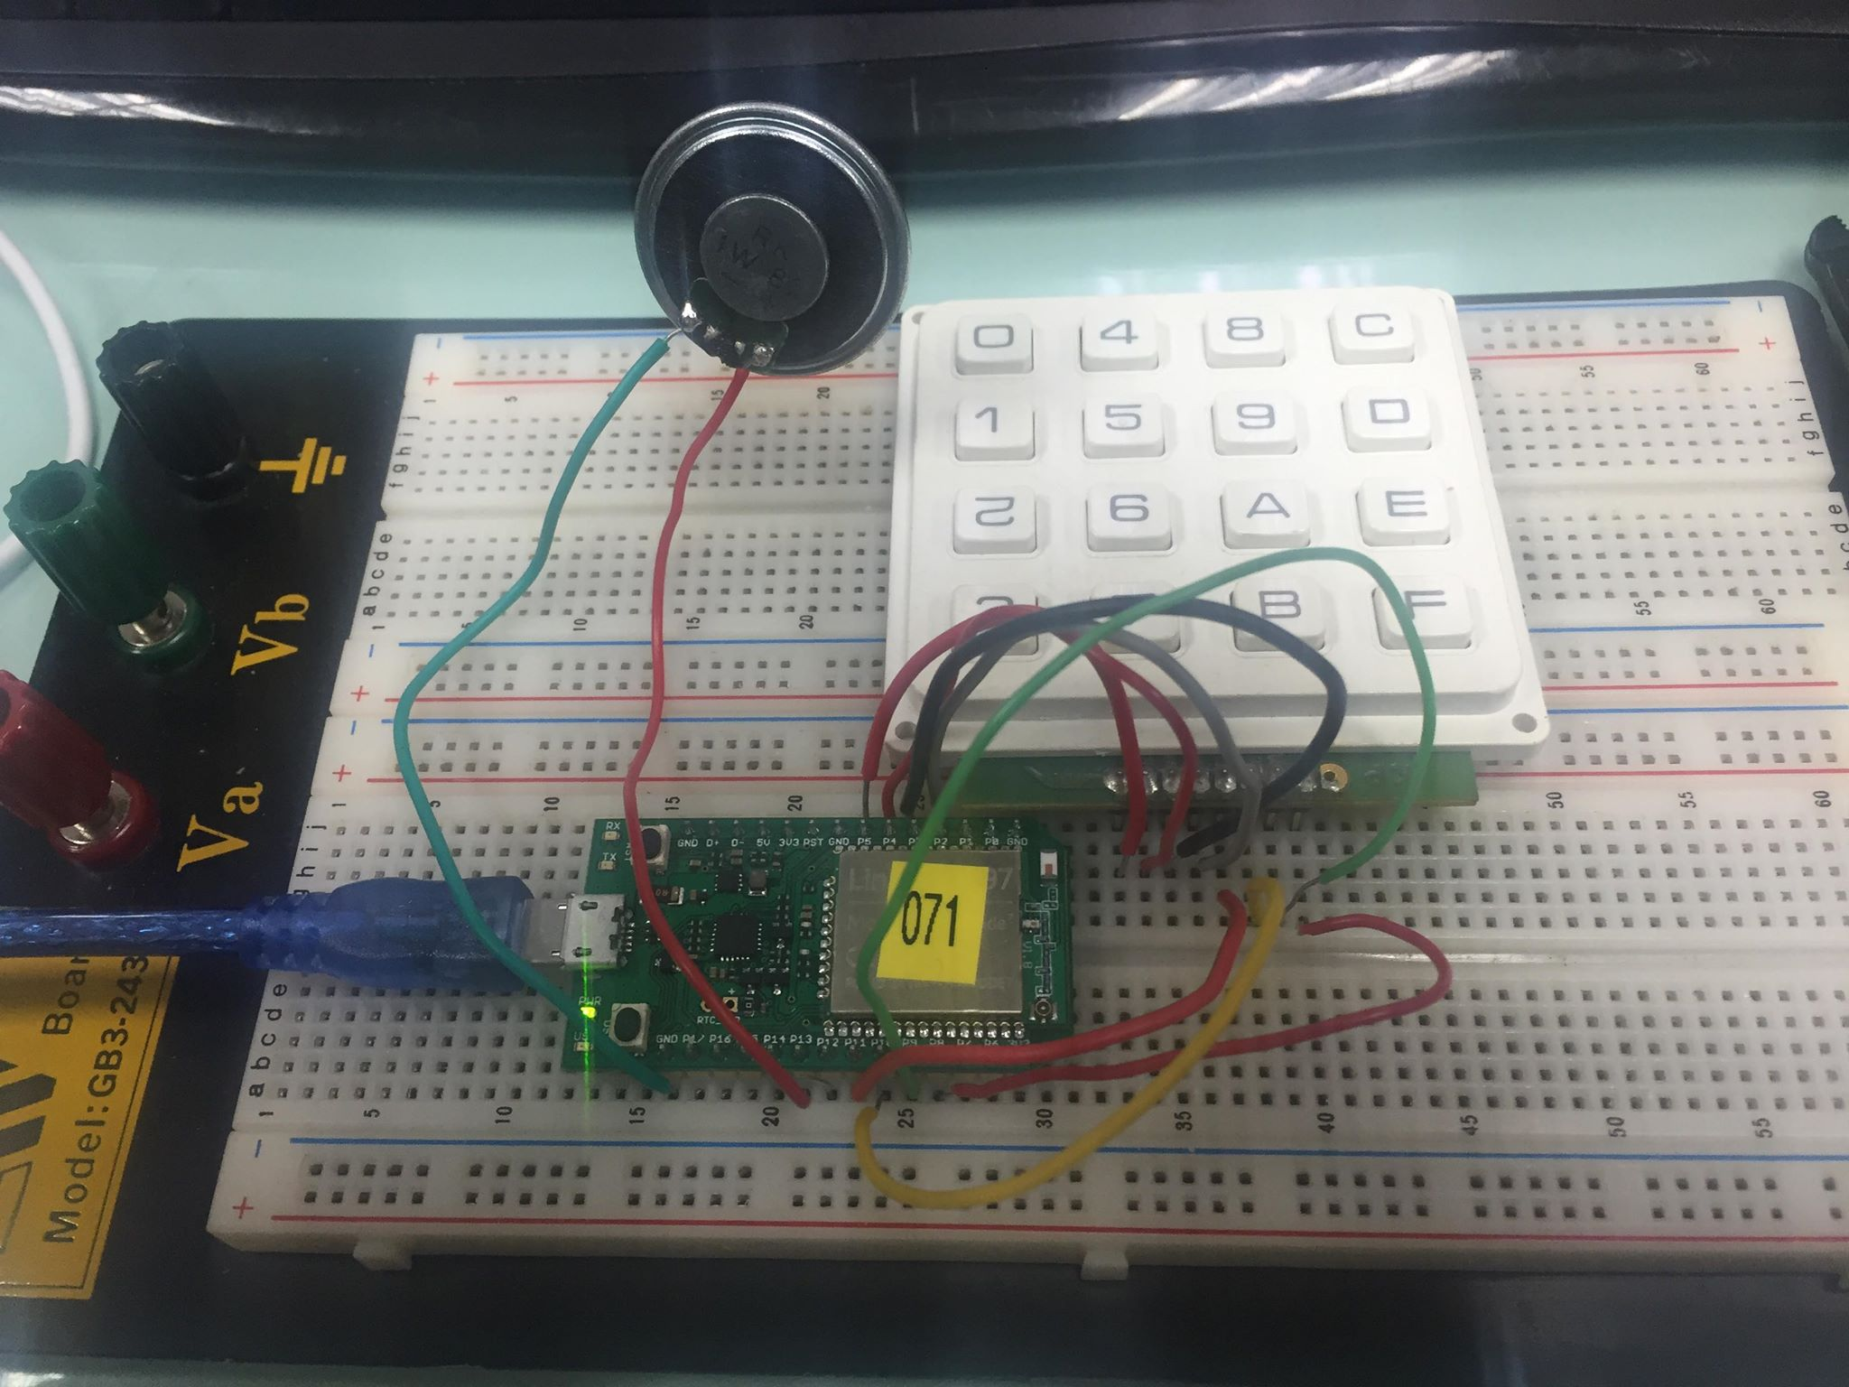
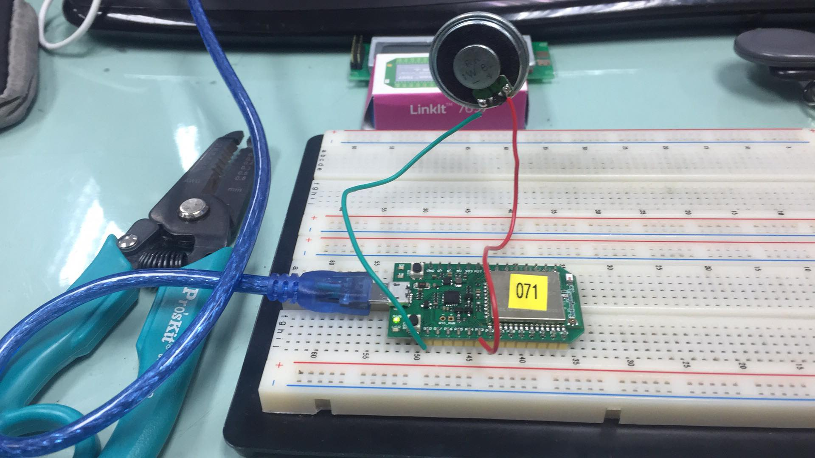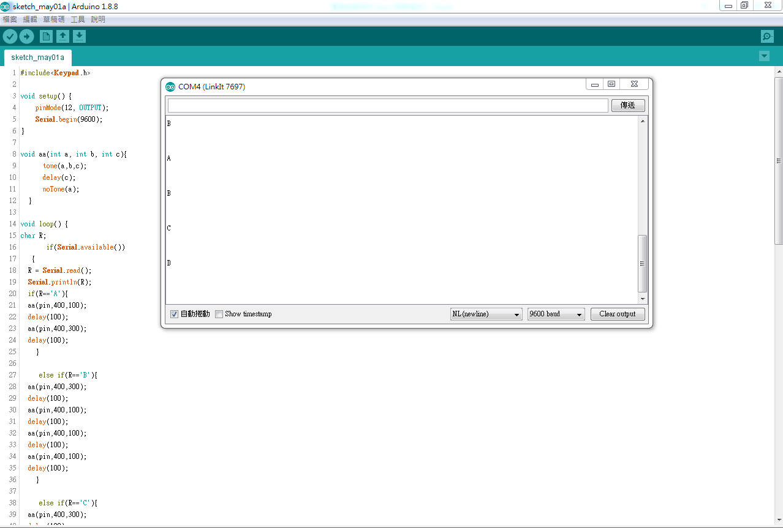

- 心得討論

這次的實驗還滿有趣的，可以用arfduino發出一首歌的聲音，希望下次也可以順利做出來。

